COVER LETTER FOR PUBLIC REVIEW DRAFT STANDARDS
CPR 183/F13

Titles: | ) DARS 1072-2023, Blend of Skimmed Milk and Vegetable Fat in Powdered form — Specification  2) DARS 1073-2023, Cheese specification  3) DARS 1076-2023, Extra hard grating cheeses — Specification  4) DARS 1078-2023, Group standard for Un-ripened cheese including fresh cheese — Specification  5) DARS 1079-2023, Cheese in Brine — Specification  6) DARS 1080-2023, Processed Cheese — Specification  7) DARS 1075-2023, Evaporated Milks — Specification  8) DARS 1096-2023, Milk Powders and Cream Powder — Specification
Document Type: | Public review drafts
Dates: | Circulation date | Closing date
 | 04 /01 /2024 | 04 /03 /2024

This Draft African Standards have been prepared by the Milk and milk products Technical Committee in accordance with the principles and procedures for Development of East Africa Standards and is now being circulated for public comments.

The Committee would appreciate any comments on this Draft Standard, which should be submitted before 04-03-2024 using the attached template. It will also be appreciated if those who have no specific comments to make but find the draft standard generally acceptable can notify us accordingly. The absence of any reply or comments shall be deemed to be an acceptance of the technical contents of the draft Kenya standard and shall constitute an approval vote.

Suggestions entailing amendments of the text should include wording preferred and the relevant clause number quoted against any comments made.

This draft standard is subject to change and should not be referred to or used as Kenyan Standard.

All correspondence pertaining to these draft standards should be addressed to the Managing Director, Kenya Bureau of Standards for the attention of Naomi Mariach

Yours faithfully,
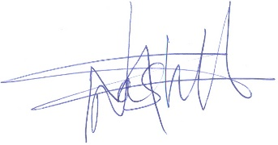
For: DIRECTOR
STANDARDS DEVELOPMENT AND INTERNATIONAL TRADE

1 | P a g e

