DRAFT EAST AFRICAN STANDARD
Textile garments — Specification — Part 6: Cardigans and sweaters

EAST AFRICAN COMMUNITY

Copyright notice
This EAC document is copyright-protected by EAC. While the reproduction of this document by participants in the EAC standards development process is permitted without prior permission from EAC, neither this document nor any extract from it may be reproduced, stored or transmitted in any form for any other purpose without prior written permission from EAC.
Requests for permission to reproduce this document for the purpose of selling it should be addressed as shown below or to EAC’s member body in the country of the requester:
© East African Community 2023 — All rights reserved
East African Community
P.O. Box 1096,
Arusha
Tanzania
Tel: + 255 27 2162100
Fax: + 255 27 2162190
E-mail: eac@eachq.org
Web: www.eac-quality.net
Reproduction for sales purposes may be subject to royalty payments or a licensing agreement. Violators may be prosecuted.

Contents Page
Foreword iv
1 Scope 1
2 Normative references 1
3 Terms and definitions 1
4 Requirements 2
4.1 Additional requirements 2
4.2 Physical and chemical requirements 2
4.3 Dimensions 2
4.4 Seams and stitches 2
4.5 Reinforcements 2
5 Labelling 3
6 Sampling 3
Annex A (informative) Dimensions of sweaters and cardigans 4
Bibliography 6
Foreword
Development of the East African Standards has been necessitated by the need for harmonizing requirements governing quality of products and services in the East African Community. It is envisaged that through harmonized standardization, trade barriers that are encountered when goods and services are exchanged within the Community will be removed.
The Community has established an East African Standards Committee (EASC) mandated to develop and issue East African Standards (EAS). The Committee is composed of representatives of the National Standards Bodies in Partner States, together with the representatives from the public and private sector organizations in the community.
East African Standards are developed through Technical Committees that are representative of key stakeholders including government, academia, consumer groups, private sector and other interested parties. Draft East African Standards are circulated to stakeholders through the National Standards Bodies in the Partner States. The comments received are discussed and incorporated before finalization of standards, in accordance with the Principles and procedures for development of East African Standards.
East African Standards are subject to review, to keep pace with technological advances. Users of the East African Standards are therefore expected to ensure that they always have the latest versions of the standards they are implementing.
The committee responsible for this document is Technical Committee EASC/TC 061, Textiles, textile products and accessories.
Attention is drawn to the possibility that some of the elements of this document may be subject of patent rights. EAC shall not be held responsible for identifying any or all such patent rights.
EAS 1141 consists of the following parts, under the general title Textile garments — Specification:
⎯ Part 1: General requirements
⎯ Part 2: Shirts
⎯ Part 3: T-shirts
⎯ Part 4: Skirts and dresses
⎯ Part 5: Jackets and coats
⎯ Part 6: Cardigans and sweaters
⎯ Part 7: Trousers and shorts

Textile garments — Specification — Part 6: Cardigans and sweaters

1 Scope
This Draft East African Standard specifies requirements, sampling and test methods for cardigans and sweaters (also known as pullovers, jumpers, sweater vests and slip overs).

2 Normative references
The following documents are referred to in the text in such a way that some or all of their content constitutes requirements of this document. For dated references, only the edition cited applies. For undated references, the latest edition of the referenced document (including any amendments) applies.
DEAS 1141-1, Textile garments — Specification — Part 1: General requirements
ISO 2859-1, Sampling procedures for inspection by attributes — Part 1: Sampling schemes indexed by acceptance quality limit (AQL) for lot-by-lot inspection
ISO 3759, Textiles — Preparation, marking and measuring of fabric specimens and garments in tests for determination of dimensional change
ISO 5077, Textiles — Determination of dimensional change in washing and drying
ISO 6330, Textiles — Domestic washing and drying procedures for textile testing
ISO 12945-2, Textiles — Determination of fabric propensity to surface pilling, fuzzing or matting — Part 2: Modified Martindale method
ISO 18890, Clothing — Standard method of garment measurement

3 Terms and definitions
For the purposes of this document, the terms and definitions given in ISO 8498 and ISO 8499 and the following apply.
ISO and IEC maintain terminological databases for use in standardization at the following addresses:
— ISO Online browsing platform: available at http://www.iso.org/obp
3.1
cardigan
knitted garment with or without sleeves, having a front opening, and with or without a fastening and usually worn over other clothes
3.2
sweater
closed outer garment, with or without sleeves, made of knitted material that covers the upper part of the body
3.3
chest girth
maximum horizontal girth measured during normal breathing with the subject standing upright and the tape-measure passed over the scapulae under the armpits and across the chest

4 Requirements

4.1 Additional requirements
Sweaters and cardigans shall comply with the colourfastness, restricted chemical substances, pH, fibre composition, packaging and other general requirements specified in DEAS 1141-1.

4.2 Physical and chemical requirements
Cardigans and sweaters shall comply with the physical and chemical requirements given in Table 1 when tested in accordance with the test methods specified therein.
Table 1 — Physical and chemical requirements for cardigans and sweaters
S/N | Parameter | Requirement | Test method
i | Dimensional change, %, max. | ±5.0 | ISO 5077  ISO 3759  ISO 6330 procedure 4N
ii | Pilling resistance (500 rubs), min. | 4 | ISO 12945-2

4.3 Dimensions
The dimensions of sweaters and cardigans are as given in Annex A for guidance purposes. Garment measurements may be carried out in accordance with ISO 18890.

4.4 Seams and stitches
4.4.1 All joinings shall be stitched with overlock stitches, linking or by covering stitches.
4.4.2 The number of stitches shall not be less than three stitches per centimetre.
4.4.3 The shoulder joinings shall be suitably reinforced.
4.4.4 knit stitches should be secured in order to prevent fraying.
4.4.5 The fabric used in the manufacture of cardigans and sweaters may be treated with a suitable shrink resistance process.
4.4.6 In the case of cardigans, the welt shall be securely stitched or linked to the cardigan.

4.5 Reinforcements
The seam joining the body and the border, cuffs or sleeves or at the shoulder and other places should be reinforced suitably.

5 Labelling
Sweaters and cardigans shall comply with the labelling requirements in DEAS 1141-1.

6 Sampling
Sampling shall be done in accordance with ISO 2859-1.
Annex A
(informative)
Dimensions of sweaters and cardigans
Table A.1 contains dimensions of sweaters and cardigans for guidance purposes only. Figure A.1 and Figure A.2 are examples of a sweater and a cardigan, respectively, to show measurement points.
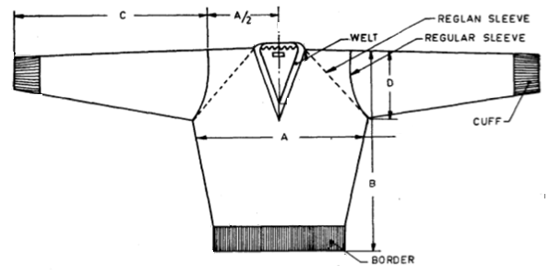
Key
A Width across chest
B Length of sweater
C Length of sleeves
D Width of opening at armhole
Figure A.1 — Example of a V-neck sweater

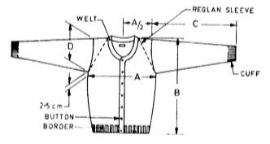
Key
A Width across chest
B Length of cardigan
C Length of sleeves
D Width of opening at armhole
Figure A.2 — Example of a round neck cardigan

Table A.1 — Dimensions of sweaters and cardigans
Size | Width across chest  inches
20 | 10
22 | 11
24 | 12
26 | 13
28 | 14
30 | 15
32 | 16
34 | 17
36 | 18
38 | 19
40 | 20
42 | 21
44 | 22

Bibliography
US 1970-7: 2021, Textile garments — Specification — Part 7: Sweaters

