DRAFT EAST AFRICAN STANDARD
Textile garments — Specification — Part 3: T-shirts

EAST AFRICAN COMMUNITY

Copyright notice
This EAC document is copyright-protected by EAC. While the reproduction of this document by participants in the EAC standards development process is permitted without prior permission from EAC, neither this document nor any extract from it may be reproduced, stored or transmitted in any form for any other purpose without prior written permission from EAC.
Requests for permission to reproduce this document for the purpose of selling it should be addressed as shown below or to EAC’s member body in the country of the requester:
© East African Community 2023 — All rights reserved
East African Community
P.O. Box 1096,
Arusha
Tanzania
Tel: + 255 27 2162100
Fax: + 255 27 2162190
E-mail: eac@eachq.org
Web: www.eac-quality.net
Reproduction for sales purposes may be subject to royalty payments or a licensing agreement. Violators may be prosecuted.

Contents Page
Foreword iv
1 Scope 1
2 Normative references 1
3 Terms and definitions 2
4 Requirements 2
4.1 Additional requirements 2
4.2 Specific requirements 2
4.2.1 Physical and chemical requirements 2
4.2.2 Dimensions 3
5 Labelling 3
6 Sampling 3
Annex A (informative) Dimensions of t-shirts 4
Annex B (informative) Recommended minimum mass per unit area 7
Bibliography 8
Foreword
Development of the East African Standards has been necessitated by the need for harmonizing requirements governing quality of products and services in the East African Community. It is envisaged that through harmonized standardization, trade barriers that are encountered when goods and services are exchanged within the Community will be removed.
The Community has established an East African Standards Committee (EASC) mandated to develop and issue East African Standards (EAS). The Committee is composed of representatives of the National Standards Bodies in Partner States, together with the representatives from the public and private sector organizations in the community.
East African Standards are developed through Technical Committees that are representative of key stakeholders including government, academia, consumer groups, private sector and other interested parties. Draft East African Standards are circulated to stakeholders through the National Standards Bodies in the Partner States. The comments received are discussed and incorporated before finalization of standards, in accordance with the Principles and procedures for development of East African Standards.
East African Standards are subject to review, to keep pace with technological advances. Users of the East African Standards are therefore expected to ensure that they always have the latest versions of the standards they are implementing.
The committee responsible for this document is Technical Committee EASC/TC 061, Textiles, textile products and accessories.
Attention is drawn to the possibility that some of the elements of this document may be subject of patent rights. EAC shall not be held responsible for identifying any or all such patent rights.
EAS 1141 consists of the following parts, under the general title Textile garments — Specification:
⎯ Part 1: General requirements
⎯ Part 2: Shirts
⎯ Part 3: T-shirts
⎯ Part 4: Skirts and dresses
⎯ Part 5: Jackets and coats
⎯ Part 6: Cardigans and sweaters
⎯ Part 7: Trousers and shorts

Textile garments — Specification — Part 3: T-shirts

1 Scope
This Draft East African Standard specifies requirements, sampling and test methods for T-shirts such as sports t-shirts, polo, crew neck and vests

2 Normative references
The following documents are referred to in the text in such a way that some or all of their content constitutes requirements of this document. For dated references, only the edition cited applies. For undated references, the latest edition of the referenced document (including any amendments) applies.
DEAS 1141-1, Textile garments — Specification — Part 1: General requirements
ISO 105-B01, Textiles — Tests for colour fastness — Part B01: Colour fastness to light: Daylight
ISO 105-X12, Textiles — Tests for colour fastness — Part X12: Colour fastness to rubbing
ISO 139, Textiles — Standard atmospheres for conditioning and testing
ISO 2859-1, Sampling procedures for inspection by attributes — Part 1: Sampling schemes indexed by acceptance quality limit (AQL) for lot-by-lot inspection
ISO 3801, Textiles — Woven fabrics — Determination of mass per unit length and mass per unit area
ISO 5077, Textiles — Determination of dimensional change in washing and drying
ISO 6330, Textiles — Domestic washing and drying procedures for textile testing
ISO 12945-1, Textiles — Determination of fabric propensity to surface pilling, fuzzing or matting — Part 1: Pilling box method
ISO 12945-2, Textiles — Determination of fabric propensity to surface pilling, fuzzing or matting — Part 2: Modified Martindale method
ISO 12947-2, Textiles — Determination of the abrasion resistance of fabrics by the Martindale method — Part 2: Determination of specimen breakdown
ISO 13938-2, Textiles — Bursting properties of fabrics — Part 2: Pneumatic method for determination of bursting strength and bursting distension
ISO 16322-3, Textiles — Determination of spirality after laundering — Part 3: Woven and knitted garments
ISO 18890, Clothing — Standard method of garment measurement

3 Terms and definitions
For the purposes of this document, the terms and definitions given in ISO 8498 and ISO 8499 and the following apply.
ISO and IEC maintain terminological databases for use in standardization at the following addresses:
— ISO Online browsing platform: available at http://www.iso.org/obp
3.1
T-shirt (or tee-shirt)
short sleeved, long sleeve or sleeveless knit-outerwear with or without a color and folded rib tape attached to the neck and sometimes to sleeves and bottom
3.2
crew tshirt
type of a t-shirt that has a round or vee neckline with no collar
3.3
polo tshirt
form of t-shirt with a collar, placket, buttons and an optional pocket

4 Requirements

4.1 Additional requirements
T-shirts shall comply with the colourfastness, restricted chemical substances, pH, fibre composition, packaging and other general requirements specified in DEAS 1141-1.

4.2 Specific requirements

4.2.1 Physical and chemical requirements
T-shirts or the fabric used for the manufacture of T-shirts shall comply with the requirements given in Table 1 when tested in accordance with the test methods specified therein.
Table 1 — Specific requirements of T-shirts or the fabric used to manufacture T-shirts
S/No | Parametera | Requirement | Test method
i | Dimensional change, %, max. | ±6 | ISO 5077  ISO 6330, Procedure 6N
ii | Spirality | 3 | ISO 16322-3
iii | Bursting strengthb, kPa, min. | 160 | ISO 13938-2
iv | Abrasion resistance at 2 000 rubs | No specimen breakdown | ISO 12947-1  ISO 12947-2
v | Piling resistance (500 rubs), min. | 4 | ISO 12945-2
ª Recommended minimum values for mass per unit area are indicated in Annex B for guidance purposes only.
^{b} Use a test area of 50 cm².

4.2.2 Dimensions
The dimensions of t-shirts are as given in Annex A for guidance purposes. Garment measurements may be carried out in accordance with ISO 18890.
4.2.3 Number of stitches
The density of the stitches shall not be less than 3.5 stitches per centimetre.

5 Labelling
T-shirts shall comply with the labelling requirements in DEAS 1141-1.

6 Sampling
Sampling shall be done in accordance with ISO 2859-1.
Annex A
(informative)
Dimensions of t-shirts
Table A.1 and Table A.2 contain dimensions of crew-neck and polo t-shirts for guidance purposes only. Figure A.1 and Figure A.2 are examples of crew-neck and polo t-shirts to show measurement points.
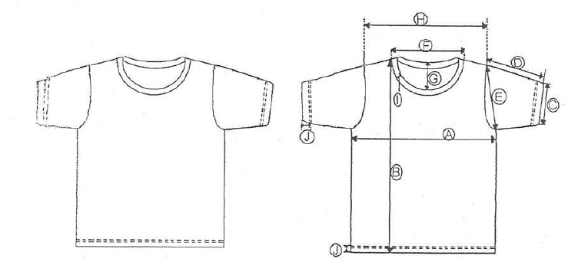
Figure A.1 — Example of a crew neck t-shirt

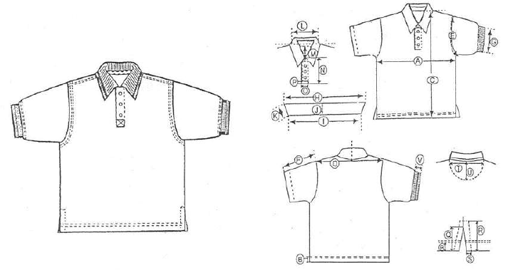
Figure A.2 — Example of a polo T-shirt
Table A.1 — Dimensions of crew neck type T-shirt
Ref | Description | Dimension  cm
Ref | Description | Small (S) | Medium (M) | Large (L) | Extra-large (XL) | Extra extra large (XXL) | Extra extra extra large (XXXL)
A | ½ chest flat | 50 | 53 | 56 | 59 | 64 | 66
B | Full length | 68 | 70 | 73 | 75 | 78 | 80
C | ½ sleeve opening | 18 | 19 | 20 | 21 | 22 | 23
D | Sleeve length | 19.5 | 20 | 21 | 2.5 | 22.5 | 23
E | Armhole (straight) | 24 | 25 | 27 | 28 | 29 | 30
F | Neck width (seam to seam) | 18 | 18 | 19 | 19 | 19.5 | 20
G | Neck drop | 7.5 | 7.5 | 8 | 8 | 8 | 8
H | Across shoulders | 48 | 51 | 54 | 57 | 59 | 61
I | Rib width | 2.5 | 2.5 | 2.5 | 2.5 | 2.5 | 2.5
J | Hem height | 2 | 2 | 2 | 2 | 2 | 2

Table A.2 – Dimensions of polo type T-shirt
Ref | Description | Dimension  cm
Ref | Description | S | M | L | XL | XXL
A | ½ Chest width - 1” below armhole | 52 | 56 | 60 | 64 | 66
B | Hem bottom | 2 | 2 | 2 | 2 | 2
C | Front length | 74 | 76 | 48 | 80 | 82
D | Shoulder to shoulder | 47 | 49.5 | 52 | 54 | 57
E | Armhole (straight) | 24.75 | 24.75 | 25.5 | 26 | 26.75
F | Sleeve length (from shoulder seam) | 24 | 24.75 | 25.5 | 26 | 26.75
G | ½ Cuff/ Sleeve opening | 16 | 17 | 18 | 18 | 19
H | Collar- point to point | 35.75 | 38.25 | 40.75 | 43.25 | 43.25
I | Neck circle (closed at neck seam) | 39.5 | 42 | 44.5 | 47 | 47
J | Collar height | 8.25 | 8.25 | 8.25 | 8.25 | 8.25
K | Collar points | 7.5 | 7.5 | 7.5 | 7.5 | 7.5
L | Neck width (seam to seam) | 18.5 | 19.25 | 20 | 20.75 | 21
M | Front neck drop | 6 | 6.5 | 7 | 7.5 | 7.5
N | Front placket length | 15.5 | 15.5 | 15.5 | 15.5 | 15.5
O | Front placket width | 3.5 | 3.5 | 3.5 | 3.5 | 3.5
P | Placket box stitch | 0.75 | 0.75 | 0.75 | 0.75 | 0.75
Q | Side vents opening | 6.25 | 6.25 | 6.25 | 6.25 | 6.25
R | Side vent stitch length | 7.5 | 7.5 | 7.5 | 7.5 | 7.5
S | Side vent double fold width | 1 | 1 | 1 | 1 | 1
T | Locker patch width | 18 | 19 | 20 | 20.5 | 20.5
U | Locker patch length | 10 | 10.75 | 11.5 | 12 | 12.5
V | Cuff height | 2.5 | 2.5 | 2.5 | 2.5 | 2.5

Annex B
(informative)
Recommended minimum mass per unit area
Table B.1 shows minimum mass per unit area for the different categories of t-shirts
Table B.1 — Recommended minimum mass per unit area for crew neck and polo T-shirts
Mass per unit area, g/m², min. | Requirement |  | Test method
Mass per unit area, g/m², min. | Natural fibres | Man-made and natural fibre blends | Test method
Crew-neck (plain) T-shirt:  - Lightweight crew neck body fabric  - Heavyweight crew neck body fabric  - Neck fabric | 140  180  200 | 85  120  180 | ISO 3801
Polo t-shirt:  - Lightweight polo body fabric  - Heavyweight polo body fabric  - Collar/cuff fabric | 180  210  600 |  | ISO 3801

Bibliography
US 1968: 2019, Textiles — Cotton T-shirts — Specification

